#TheHunt
Explore historic Frankfort Avenue in a new, fun-filled (and socially distant) way! On this epic scavenger hunt, you will search cultural attractions and iconic places along the Avenue – many of which connected to KSBCF.
Start at Crescent Hill Library (2762 Frankfort Ave.) and work your way down towards Pope Street hunting for these twenty, distinct places.
#The Hunt will take just over an hour to complete and each location is within easy walking distance. This is ideal to do on your own, with your family, or small group.
If you complete #TheHunt the fastest – you can win a $25 gift card to Carmichael Bookstore and $25 gift card to Heine Brothers Coffee.
How to play?
Take a picture of yourself/group in front of each of the clued locations. Upload your picture to any social media account (Facebook, Twitter, or Instagram), tag KSBCF and use the hashtag #TheHunt.
The fastest time will be based on the amount of time between the first photo uploaded to the last photo from the same account (all 20 spots must be correct). Please use just one social media platform and account to play. Winner will be announced August 28th during Quiz-antine (Trivia Night) on Facebook Live.

Clue #1
It’s a place that is a nice relief from the summer heat; however, you may want to wear your comfy pants if you step into this shop.

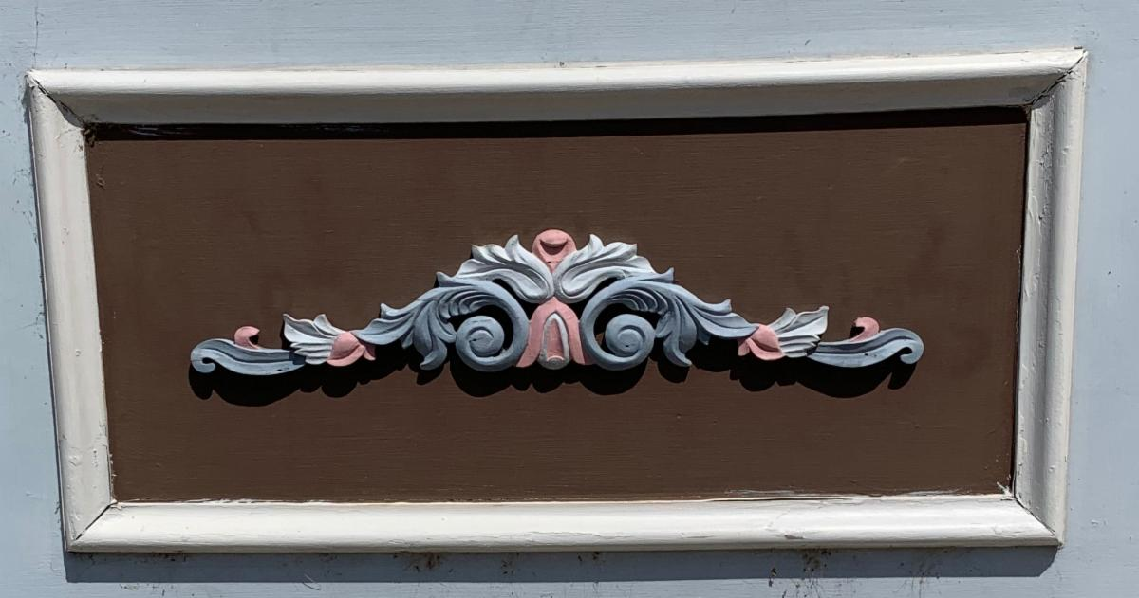

Photo: Ornate, turn-of-the-century decal on a side of a building painted in blue, cream, and pink.

Clue #2
If you brought your fur-baby along on this hunt – pop in this shop to get your best friend a homemade treat.

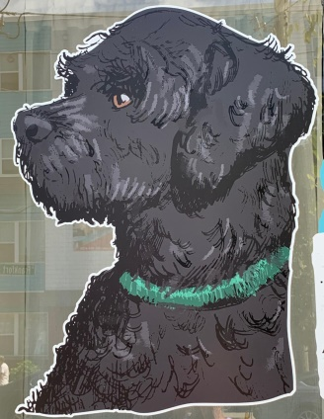

Photo: Painted profile of a dog with a green collar
Clue #3
I’m a piece of public art for you to stop and admire as you make your way down the Avenue.

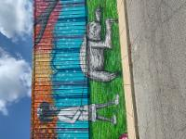

Photo: Mural on the side of a building depicting a girl walking a sloth on a leash.

Clue #4
Red, white, or blush? Whatever you fancy, this shop features selections from California, to France, Australia, and even from down the road.

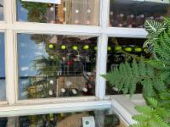

Photo: A glass store front lined with bottles
Clue #5
A cozy, woman owned local where you can satisfy your hunger cravings.

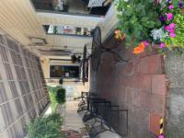

Photo: Covered, brick-lined patio area with outside tables and chair with flower pots.

Clue #6
An eclectic and eccentric shop for all your clothing and accessory needs. During the school year, you may find some Kentucky School for the Blind students helping out with the shop.

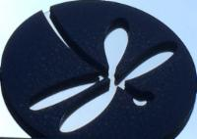

Photo: Metal circle with a cut out of an insect with four wings and a long body.

Clue #7
A culinary staple since the 1990s where you can stop in for lunch and enjoy Mediterranean treats!
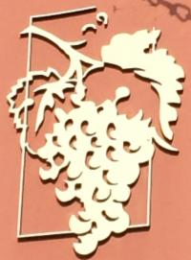
Photo: Detailed relief of a cluster of grapes

Clue #8
This Louisville based store has been around for 40 years – twenty of which in Crescent Hill. An ideal shop for gifts and puzzles, but its’ selling point is a particular item that helps pass the time and lets your imagination soar.
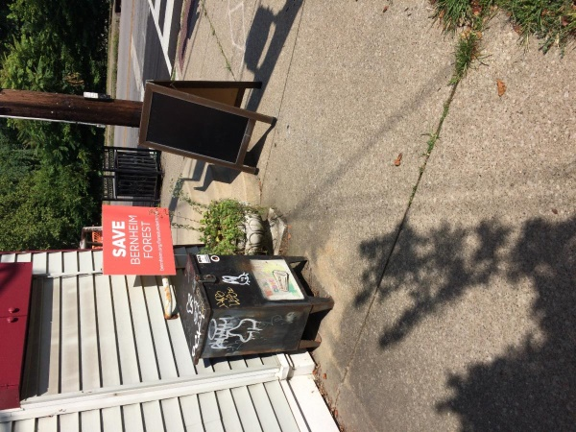
Photo: Building on a street corner with a graffiti metal box, “Save Bernheim Forest” sign, and a blank chalkboard.

Clue #9
Another Louisville staple found all across the city. If you are feeling a little sleepy from your travels, pop right in this shop and it will perk you right up.

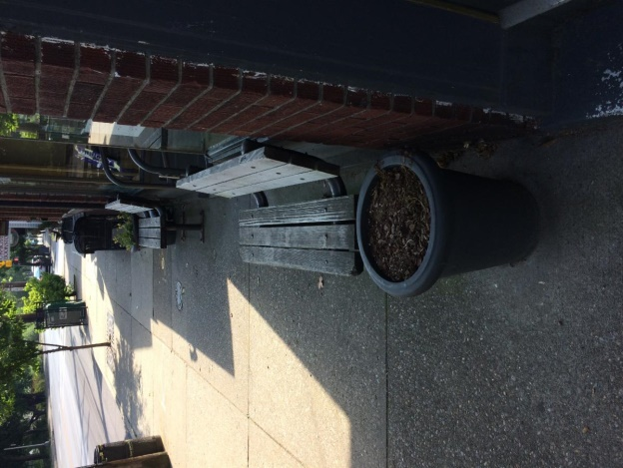
Photo: Two benches in front of a shop with flower pots on either side

Clue #10
Fun fact! Nearly 100 years ago this site was a workshop for adults who were blind and visually impaired. Now it is an after work spot with a “bubbly” name.

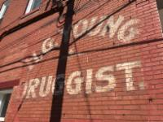
Photo: Side of a brick building with “H.G. Druggist” painted across in faded lettering

Clue #11
Another culinary wonder on the Avenue and, on some warm nights, you may hear musicians serenading diners on their open patio.

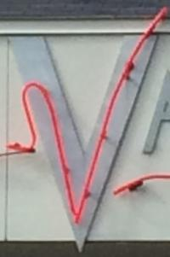
Photo: The letter “V” accented with neon lights.

Clue #12
A quirky joint and perfect if you are craving some south-of-the-border cuisine
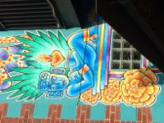
Photo: Mural on the side of a brick building depicting a Mesoamerican-style statue of a person with a flaming heart floating above, the image is outlined by yellow flowers and agave leaves.
Clue #13
This site is a long time fixture on Frankfort Avenue and strong relationship with the Kentucky School for the Blind and the charitable foundation. During the week you may tour factory and even its on-site museum.

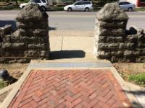
Photo: Brick walkway leading to a stone-pillared exit to the sidewalk along Frankfort Ave.

Clue #14
This shop proves that there is more than one way a person can enjoy Kentucky’s most popular export, and you don’t even need to be 21 years old.

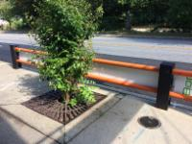
Photo: Taken on the sidewalk looking at Frankfort Ave. with a barrier lining the street with orange posts and a tree.

Clue #15
If you feel your sweet tooth calling, you may want to surrender yourself to this shop’s sweet treats and baked goods.
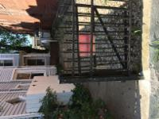
Photo: A cast-iron gate next to a walkway with a pea gravel patio area that leads to the side entrance of a shop.

Clue #16
Since the mid 1800’s this site has been an educational institution and home to students across Kentucky. This cupola is one of the remaining features of this site’s original building that was unfortunately destroyed in a fire over fifty years ago.
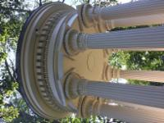
Photo: White pillars holding the domed roof of this outdoor feature.
Clue #17
This shop is a little bit of everything you need. A casual restaurant, retail, soups, baked goods and even butcher shop – everything to get you ready for dinner!
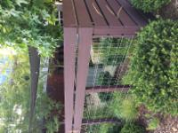
Photo: Outdoor patio are lined with a wooden fence, sun sail, and Edison lights draped across.

Clue #18
This building has been on the Avenue for over 150 years as a saloon, grocery and dry goods store. Nowadays it’s a local favorite if you want a taste of the Emerald Isle.
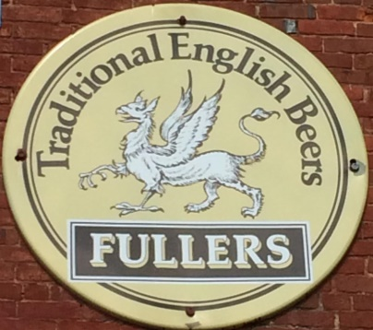
Photo: Metal sign fixed to a brick wall and reads, “Traditional English Beers Fullers” with a winged creature in the middle.
Clue #19
When you hear this shop’s name you may think WWII and nuclear tests; however, it’s a perfect spot for sports and good comfort food.
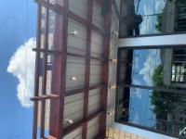
Photo: Store front looking up to the metal awning with Edison lights hanging down.

Clue #20
Italian eatery boasts a Tuscan style atmosphere that is ideal for date night and a perfect spot for a blue horse statue.
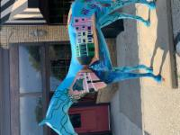
Photo: Blue statue of a horse with a street and buildings painted on it, set in front of brick building with a red door.

