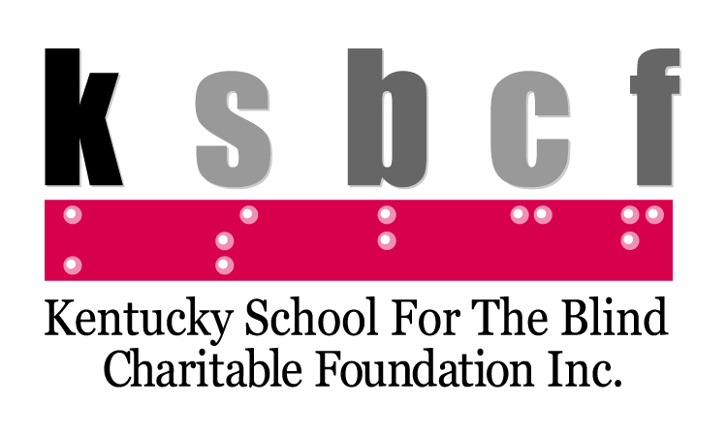
2020 Golf Scramble Sponsorship Packages

Tee Sponsors - $150
- Recognition on signage placed at a specific tee on the course
- Inclusion in event program and sponsor thanks signage
Drink Cart Sponsor - $300
- Recognition on signage placed on the two drink carts
- Listing on KSBCF website
- Inclusion in event program and sponsor thanks signage

Putting Contest Sponsor - $500
- Recognition on signage placed at the putting contest location
- Listing on KSBCF website
- Inclusion in event program and sponsor thanks signage
- Recognition in print and e-mail promotions

Gift Bag Sponsor - $1,000
- Recognition on outside of gift bag and/or gift itself provided to each golfer
- Inclusion of sponsor’s own promotional materials in every gift bag
- Listing on KSBCF website
- Inclusion in event program and sponsor thanks signage
- Acknowledgement of sponsor announced during the event
Dinner Sponsor - $1,500
- Recognition on signage placed near the dinner buffet location
- Inclusion of sponsor’s own promotional materials on every table
- Listing on KSBCF website
- Inclusion in event program and sponsor thanks signage
- Recognition in print and e-mail promotions
- Acknowledgement of sponsor announced during the event
- Registration for one team of four to play in the tournament

Event Title Sponsor - $2,500
- Recognition on event registration materials and in all promotional materials
- Inclusion of sponsor’s own promotional materials in gift bag
- Recognition on event welcome banner
- Listing on KSBCF website
- Inclusion in event program and sponsor thanks signage
- Acknowledgement of sponsor announced during the event and opportunity for sponsor to speak
- Registration for one team of four to play in the tournament

All or part of your sponsorship may be tax deductible
as a charitable contribution.
KSBCF Golf Scramble Sponsorship (event is Thursday, September 24, 2020)
Organization Name (if applicable): _________________________________________________________
Contact Person: _______________________________________________________________________
Phone: __________________________ E-mail: _____________________________________________
Name as you want it to appear on signage: ____________________________________________________________
□ I am unable to be a sponsor, but would like to make a donation of: __________________________
□ Tee Sponsor ($150)
□ Drink Cart Sponsor ($300)
□ Putting Contest Sponsor ($500)
□ Gift Bag Sponsor ($1,000)
□ Dinner Sponsor ($1,500)
□ Event Title Sponsor ($2,500)
Please contact us or return this form along with a check made payable to the Kentucky School for the Blind Charitable Foundation. Sponsors should confirm with payment as soon as possible to ensure inclusion in print, electronic, and sign promotions.
Send to KSBCF by mail to 214 Haldeman Avenue, Louisville, KY 40206. For questions or further information, contact the Kentucky School for the Blind Charitable Foundation at (502) 897-3990 or nroth@ksbcf.org.

