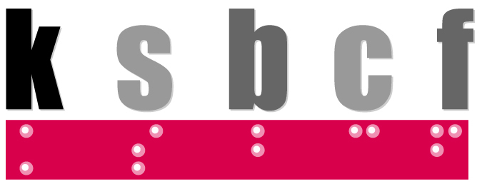

Kentucky School for the Blind Charitable Foundation
A 501(c)(3) non-profit organization

Bluegrass Bash
Sponsorship Packages

Friday, September 30, 2022 ~ Farmington Historic Home ~
6:00pm Cocktails and Silent Auction ~ 7:15 pm Dinner
$100 per person by Sept. 2/$125 after Sept. 2 ~ $1,000 table of 10 by Sept. 2/$1,250 after Sept. 2

Join us for a celebration of the Bluegrass Bash, an annual fundraising event that includes dinner, drinks, auctions, and music to benefit the Kentucky School for the Blind Charitable Foundation. This year’s event will be held at Farmington Historic Home’s beautiful grounds and will feature a Bluegrass themed celebration with dinner, drinks, music, games, and fun for all! The gala also includes entertainment and auctions. Proceeds support the Charitable Foundation’s mission to make a difference in the education, independence, and quality of life for blind and visually impaired students and individuals in Kentucky.

Sponsorship Packages

Table Sponsor - $150
- Recognition on table number sign – “This table sponsored by _____”
- Recognition on sponsor signage
- Listing on event page
Table Centerpiece Sponsor - $250
- Recognition on or near the floral centerpiece on each table
- Listing on KSBCF website – www.ksbcf.org and all social media
- Recognition on sponsor signage
Gift Bag Sponsor - $500
- Recognition on the gift packaging provided at each place setting
- Listing on KSBCF website – www.ksbcf.org and all social media
- Recognition on sponsor signage
- Two tickets to event
Reception Sponsor - $1,000
- Recognition on event invitation and promotional materials
- Listing on KSBCF website – www.ksbcf.org
- 1 social media post on KSBCF account
- Recognition on sponsor signage in and around the reception/silent auction area
- Acknowledgement announced by emcee or KSBCF representative during the event
- Four tickets to event
Event Title Sponsor - $3,000
- Recognition on event invitation and all promotional materials
- Listing on KSBCF website and event page
- 3 social media posts on KSBCF accounts
- Title event sponsor recognition on all event signage
- Acknowledgement announced by emcee or KSBCF representative
- Table for ten at event

Auction Items
Gift certificates and product donations are greatly appreciated and will help us raise much-needed funds for educational tools and scholarships. Businesses, organizations, and individual donors will receive a letter acknowledging their generous donation, and will be recognized on event signage and on the KSBCF website. Thank you for your support!
To make a donation, please visit www.ksbcf.org or please make checks payable to:
Kentucky School for the Blind Charitable Foundation
214 Haldeman Ave, Louisville, KY 40206
For more information, please contact us: (502) 897-3990 or nroth@ksbcf.org

