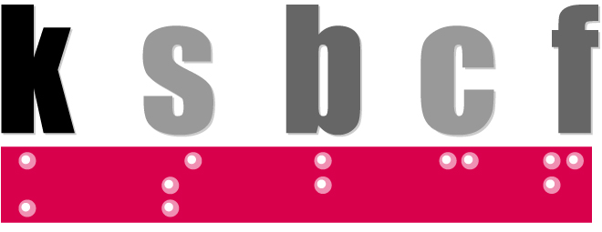
Kentucky School for the Blind Charitable Foundation

GRANT APPLICATION GUIDELINES
Requirements for Submission of Grant Requests:
- Requests for funding will only be accepted through submission of a grant application.
- Application Deadline: Requests must be submitted by January 1, April 1, July 1, or October 1 for consideration.
- Applicants must be blind or visually impaired and a resident of Kentucky or must be an organization that serves those who are blind or visually impaired in Kentucky.
- Applicants who need assistance completing grant forms or require a specific format may contact our office at (502) 897-3990.
Applicants Must Submit the Following Documents with the Application:
- Student applicants must include a low vision eye exam done within the last three years.

- Student applicants grades K-12 must include a copy of the student IEP.

- Student applicants grades K-12 must include either an Assistive Technology Evaluation or Functional Learning Media Assessment.
- Student applicants grades K-12 must include a letter from a Teacher of the Visually Impaired (TVI) specifying the need for the equipment/grant.
- College student applicants must submit a letter of recommendation from a teacher, counselor, or other professional.
- Kentucky Office of Vocational Rehabilitation/Office for the Blind (OFB) clients must submit a letter of recommendation from a Vocational Rehabilitation/OFB counselor.

Incomplete applications and/or applications without
supporting documents will be returned.
Kentucky School for the Blind Charitable Foundation
GRANT APPLICATION FORM
Individual Applicant

Name: __________________________________________________ Birth Date: _____/_____/_____

Address: __________________________________________________________________________

City: _______________________________________ State: ____________ Zip: _________________

Phone: (home) ____________________ (work) ____________________ (cell) ___________________

E-mail address: _____________________________________________________________________

Is the applicant a student? ___________ Grade level: __________ TVI: ________________________
School Attending: ________________________________________ County: ____________________
Is the applicant a client of Vocational Rehabilitation/Office for the Blind?____ Counselor:______________
Is the applicant enrolled in: vocation training college courses Other: ___________________

Name of College/Workplace: __________________________________________________________
Eye Condition / Acuity: _______________________________________________________________
Name of parent/guardian (if applicable): __________________________________________________

Organization Applicant

Contact: _____________________________ Executive Director/Administrator: __________________

Organization: ______________________________________________________________________

Address: __________________________________________________________________________

City: _______________________________________ State: ____________ Zip: _________________

Phone: ____________________ Website: ______________________ E-mail: ____________________
Is the organization a 501(c)(3)? _______ Please provide the Federal ID number: __________________
Number of employees: _____________ Annual operating budget: _____________________________

Services provided: ___________________________________________________________________
___________________________________________________________________________________

Mission statement: ___________________________________________________________________
___________________________________________________________________________________

Type (adults, children, elderly, etc.) and number of population served: ___________________________

___________________________________________________________________________________
Grant Request
You must include either a dollar amount for a grant funding request or list the type of assistive technology requested with an estimated cost.
Grant dollar amount requested (if applicable): $ ____________________
Assistive technology requested (if applicable): _____________________________________________

Estimated cost of assistive technology: $ ____________________

Purpose of the Grant: Date needed: ____________________
Please provide a brief statement explaining the purpose of the grant request addressing the following:

- Detailed description of the request (i.e. provide the reason for the request/need, the specifications of assistive technology/ equipment, etc.)
- Explain how the grant or assistive technology will make a difference to your current situation.
- Budget and/or itemization of cost(s)
- Any additional relevant information

If requesting assistive technology, please include an impact statement addressing the following:

- What specific activities is the requested device needed for?
- How will the requested device help with those activities and/or needs?
- How will the device benefit the applicant?
- Does the applicant know how to effectively use the requested device or will the applicant need training? If so, who will provide the training?
Has the applicant had an assessment by a Low Vision Specialist, TVI, OFB Technology Specialist or other appropriate evaluation? YES NO (If yes, please attach a copy of the assessment)

Has funding been requested from any other source (i.e. school system, special education cooperative, Office for the Blind)? YES NO

If yes, list the organizations or agencies to which you requested funding:
___________________________________________________________________________________________
What is the status? Pending Funded (Amount $____________ ) Not Funded

If not funded, please list the reason for denial: _____________________________________________
__________________________________________________________________________________
I hereby state that I answered the above information accurately and to the best of my ability.

_________________________________________ ___________________
Signature of Applicant or Parent/Guardian Date

Please submit this application to:
Kentucky School for the Blind Charitable Foundation Fax: (502) 897-3194
Attn: Grant Review Committee E-mail: mbrown@ksbcf.org
214 Haldeman Avenue
Louisville, Kentucky 40206 Phone: (502) 897-3990
OFFICE USE ONLY Date Application Received: ________________
Notes: _____________________________________________________________________________________

